Screenshot triangle wave

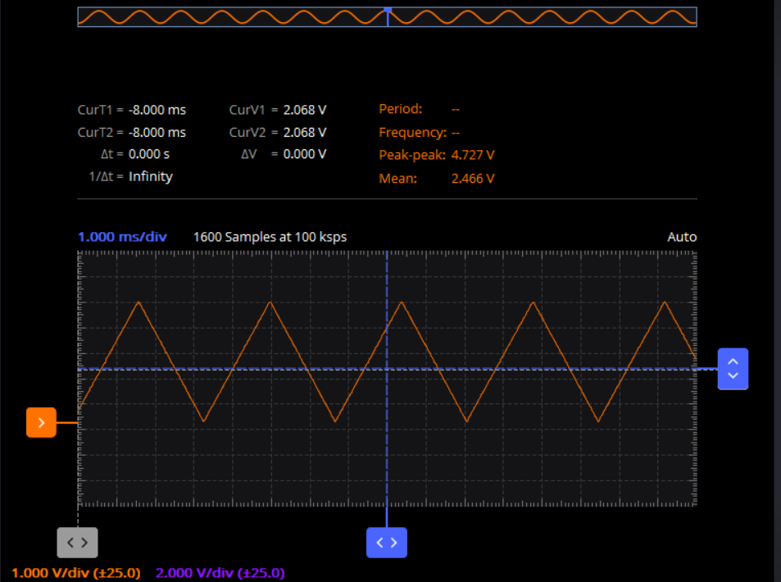  
screenshot sawtooth wave

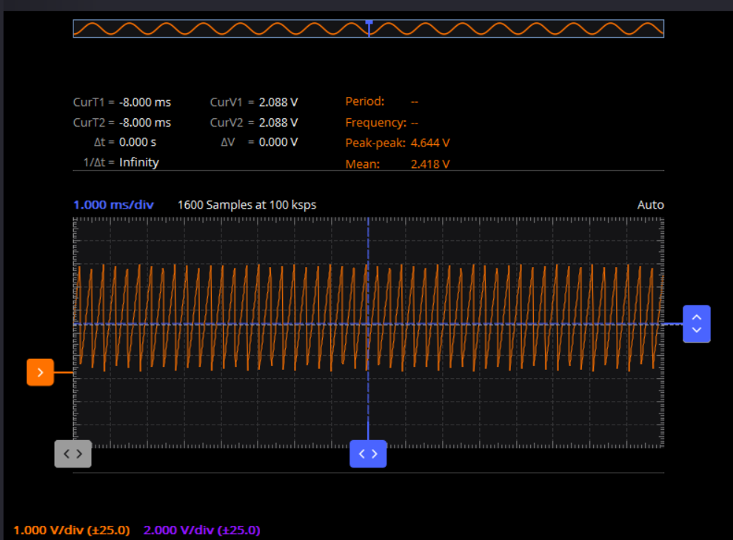

Screenshot sine wave

I took two after I changed the frequency the 2nd screenshot is with no change on the scopy setting between the first and second wave and the third I changed it to see the wave better this was because frequency wasn’t showing up on my scopy.

